Experiment no.:09 Keerthika.K-241901046
Study the steps for hiding and extract any text file behind an image
file/ Audio file using Command
Prompt.
Aim
To study the steps for hiding and extracting a text file behind an image file/audio file using Command Prompt.
Procedure
A. Hiding a Text File Behind an Image File
- Create a text file named A.txt containing sample text.
- Copy an image file named B.jpg to the same folder.
- Open the Run window by pressing Win + R.
- Type cmd and press Enter to open Command Prompt.
- Navigate to the Desktop directory using the command:
cd desktop
- Enter the following command to combine the text file with the image file:
copy /b B.jpg + A.txt C.jpg
- The output file C.jpg is created, containing the image and the appended text file data.
B. Retrieving the Hidden Text File
- Locate the output image file C.jpg.
- Right-click the file and open it with Notepad.
- Scroll to the end of the file.
- Examine the text content appended to the image file.
C. Hiding a Message in an Image File
- Open Command Prompt and navigate to the directory containing the image file.
- Enter the following command:
echo "Your Message">>"image.jpg"
- Open the image file using Notepad.
- Scroll to the end of the file to view the appended message.
D. Hiding Data Behind an Audio File
- Select an audio file named sound.mp3.
- Place the files to be hidden into a ZIP archive named secret.zip.
- Open Command Prompt in the directory containing both files.
- Use the following command to combine the files:
copy /b secret.zip + sound.mp3 newfile.mp3
- To retrieve the data, change the output file extension from .mp3 to .zip, or open newfile.mp3 using a ZIP utility.
- Examine the files contained in the archive.
Observation
The binary copy method combines the contents of a text file and an image file into a new output file. The appended text can be examined using Notepad. Similarly, data can be appended to an audio file and examined using an appropriate archive utility.
Observation Table
S. No. | Particulars | Observation
1 | Tool Used | Command Prompt
2 | Input Text File | A.txt
3 | Input Image File | B.jpg
4 | Output Image File | C.jpg
5 | Command Used | copy /b B.jpg + A.txt C.jpg
6 | Retrieval Method | Open output file using Notepad
7 | Audio File Example | sound.mp3
8 | ZIP File Example | secret.zip
9 | Output Audio File | newfile.mp3
10 | Result | hidden data was retrieved successfully
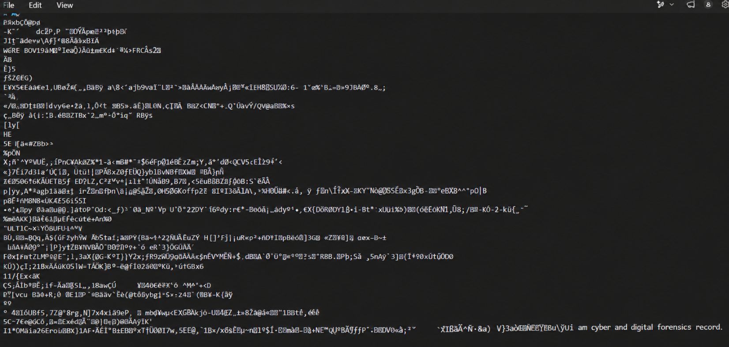

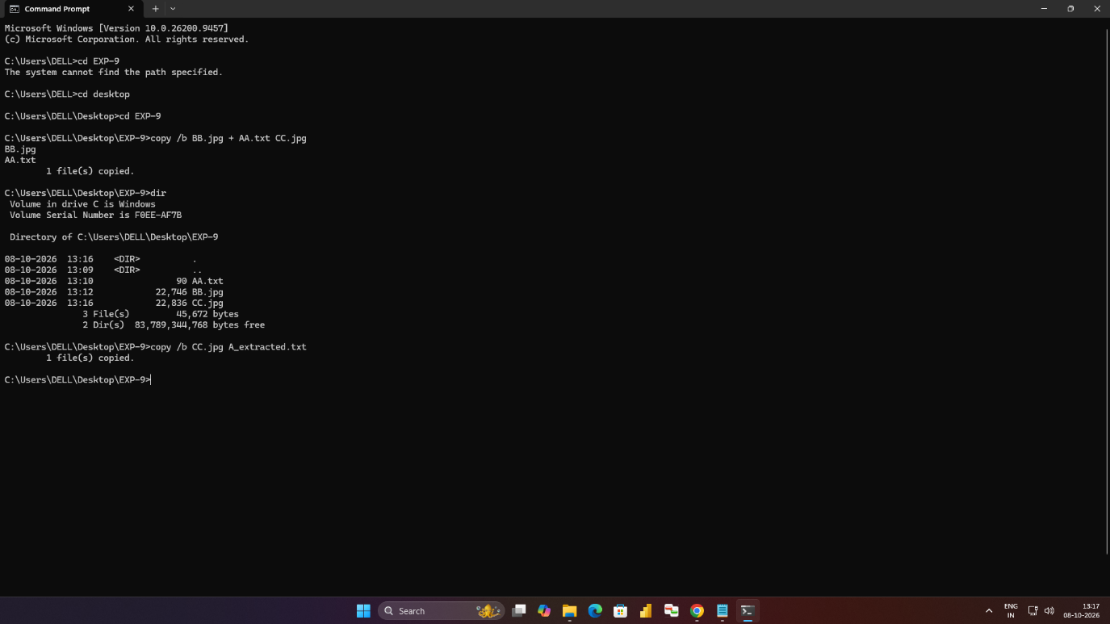

Result
Thus, the procedure for hiding and extracting text or other data behind image and audio files using Command Prompt was studied.

